18/10/2026 NAME: Charulatha.V
Experiment :2 REG.NO.:192424031
SLOT: A
SEMESTER:MS2 September 2026
COURSE CODE:CSA4701
COURSE NAME:Deep Learning

Covariance, Eigenvalues and Eigenvectors Analysis
Scenario:
A healthcare dataset contains patients' height, weight, and blood pressure. Calculate the covariance matrix to identify relationships among the features and visualize the correlations.
Algorithm:
- Start the program.
- Import NumPy, Pandas, and Matplotlib libraries.
- Get the patients' height, weight, and blood pressure data as input.
- Store the data in a Pandas DataFrame.
- Calculate the covariance matrix using the cov() function.
- Calculate the correlation matrix using the corr() function.
- Compute the eigenvalues and eigenvectors of the covariance matrix using NumPy.
- Display the dataset, covariance matrix, correlation matrix, eigenvalues, and eigenvectors.
- Visualize the correlations using a heatmap and plot the relationships between features.
- Display the graphs and interpret the results.
- Stop the program.

Source code:
import numpy as np
import pandas as pd
import matplotlib.pyplot as plt
# Healthcare dataset
data = {
"Height": [160, 165, 170, 175, 180, 168],
"Weight": [55, 60, 65, 72, 80, 63],
"Blood Pressure": [110, 115, 120, 125, 135, 118]
}
df = pd.DataFrame(data)
# Display input data
print("HEALTHCARE DATASET")
print(df.to_string(index=False))
# Summary statistics
print("\nSUMMARY TABLE")
print(df.describe().round(2))
# Calculate covariance matrix
cov_matrix = df.cov()
print("\nCOVARIANCE MATRIX")
print(cov_matrix.round(2))
# Calculate correlation matrix
corr_matrix = df.corr()
print("\nCORRELATION MATRIX")
print(corr_matrix.round(3))
# Calculate eigenvalues and eigenvectors
eigenvalues, eigenvectors = np.linalg.eigh(cov_matrix
print("\nEIGENVALUES")
print(np.round(eigenvalues, 3))
print("\nEIGENVECTORS")
print(np.round(eigenvectors, 3))
# Plot 1: Correlation heatmap
plt.figure(figsize=(7, 5))
plt.imshow(corr_matrix, cmap="coolwarm", vmin=-1, vmax=1)
plt.colorbar(label="Correlation")
plt.xticks(range(3), df.columns, rotation=20)
plt.yticks(range(3), df.columns)
plt.title("Correlation Heatmap of Healthcare Features")
for i in range(3):
for j in range(3):
plt.text(j, i, f"{corr_matrix.iloc[i, j]:.2f}",
ha="center", va="center")
plt.tight_layout()
plt.show()
# Plot 2: Height vs Weight
plt.figure(figsize=(7, 5))
plt.scatter(df["Height"], df["Weight"])
plt.xlabel("Height (cm)")
plt.ylabel("Weight (kg)")
plt.title("Relationship Between Height and Weight")
plt.grid(True, alpha=0.3)
plt.tight_layout()
plt.show()
# Plot 3: Eigenvalues
plt.figure(figsize=(7, 5))
plt.bar(["Eigenvalue 1", "Eigenvalue 2", "Eigenvalue 3"],
eigenvalues)
plt.xlabel("Principal Components")
plt.ylabel("Eigenvalue")
plt.title("Eigenvalue Analysis")
plt.tight_layout()
plt.show()
# Result
print("\nRESULT")
print("Covariance, correlation, eigenvalues and eigenvectors")
print("were calculated successfully.")
print("The correlation matrix shows strong positive")print("relationships among the three healthcare features.")
Output:
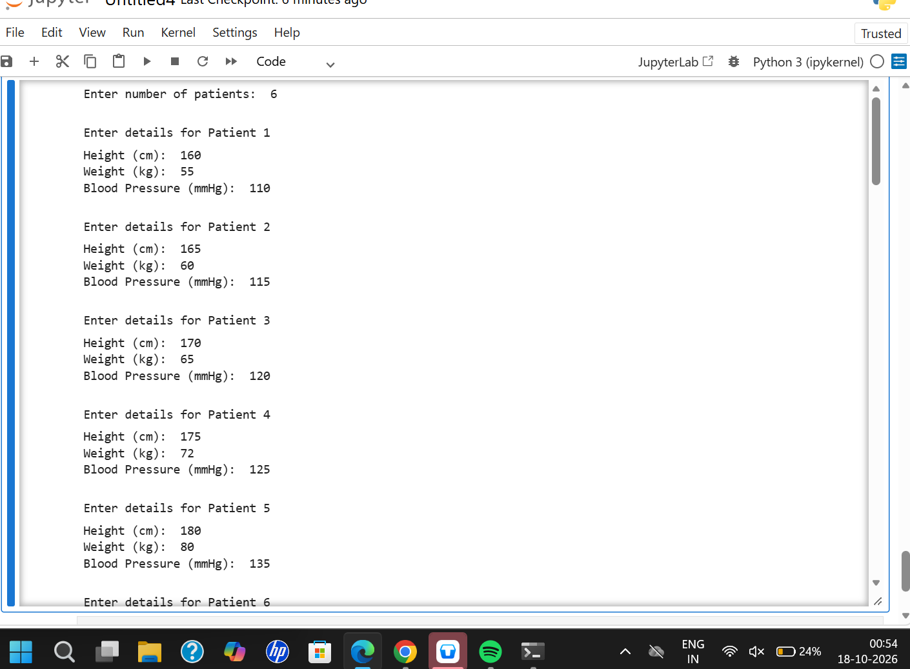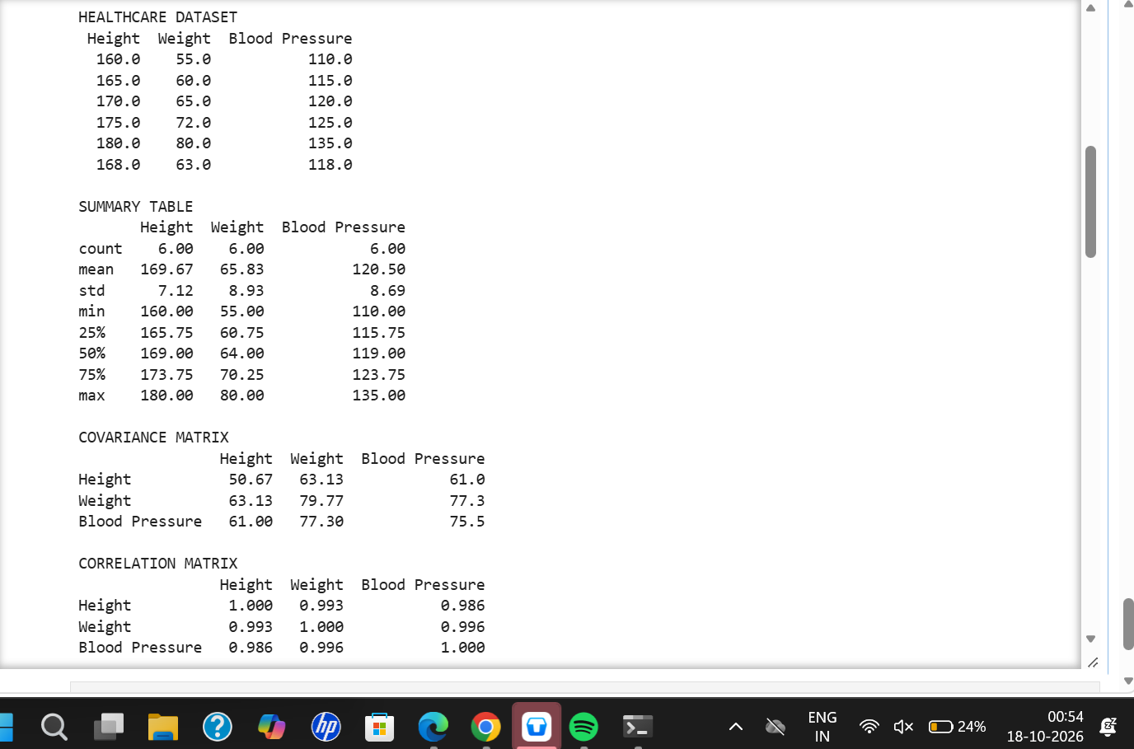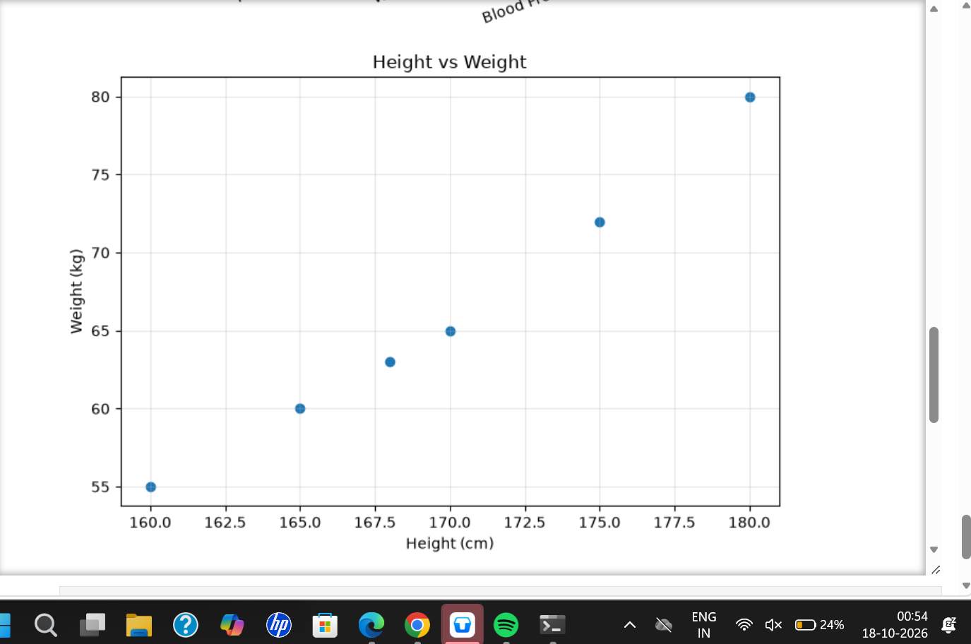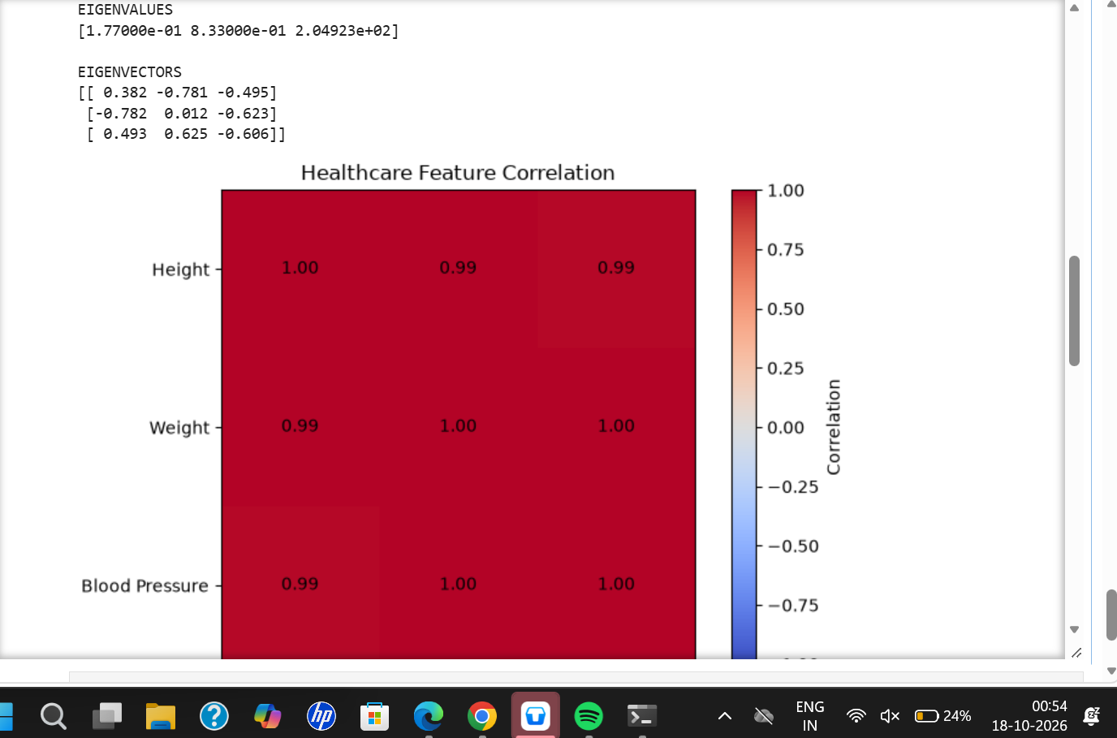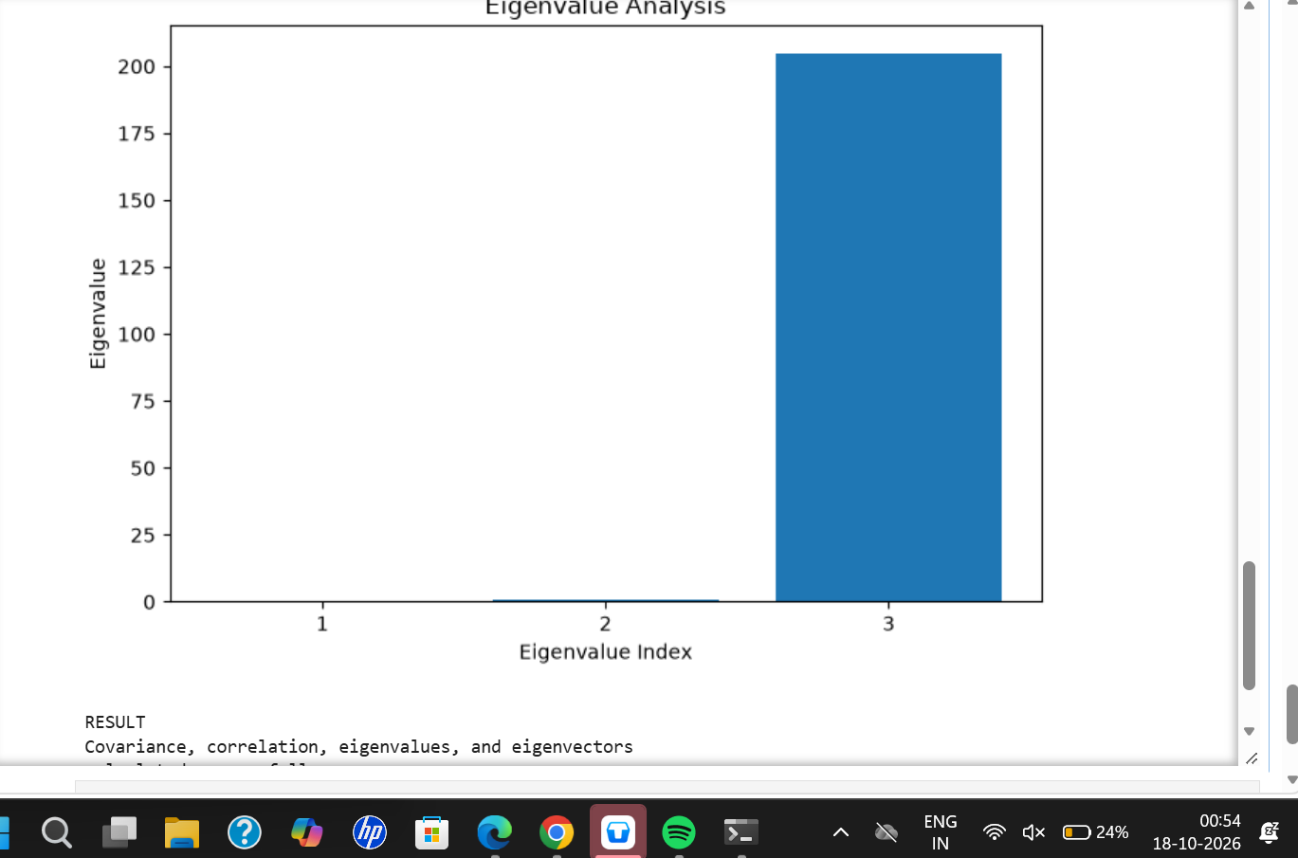
Result:
The covariance matrix, correlation matrix, eigenvalues, and eigenvectors were calculated successfully using NumPy and Pandas. Matplotlib was used to visualize the relationships among the healthcare features. The sample data shows strong positive correlations among height, weight, and blood pressure.

